# Steps to create your nuget packages

## Create your account in nuget.org

## Create an API Key there, copy it to clipboard and store somewhere in private location

## Create nuget package out of your project

In Visual Studio, enter to settings of a project you want to publish as nuget. Configure its values:

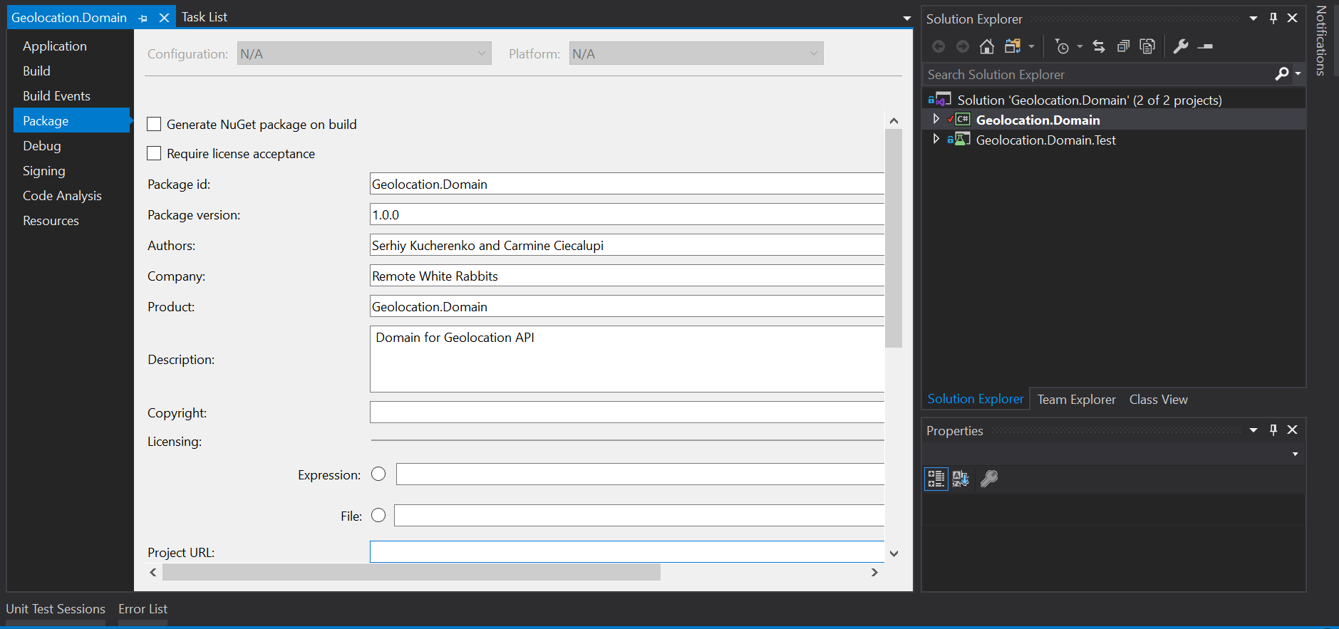

Then it is time to pack the project. Make sure to compile it in release mode first.

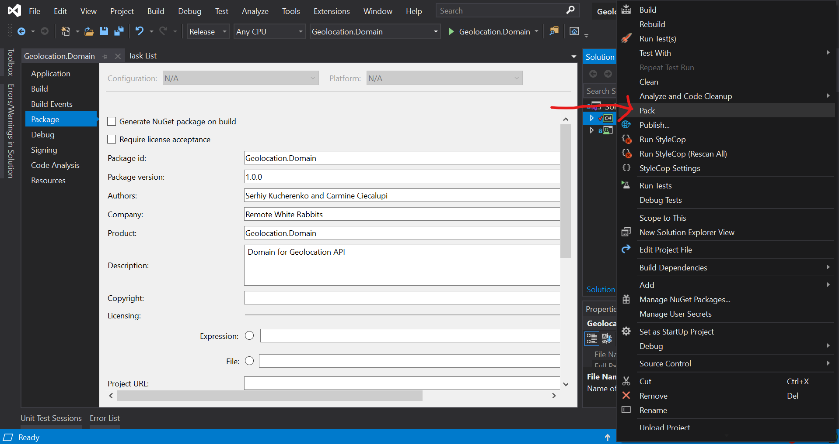

It should generate a package inside bin/release folder now

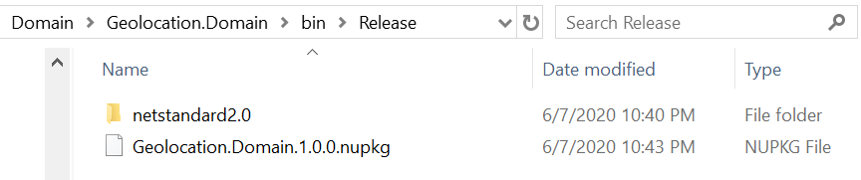

## Publish the new package

Inside that folder type “cmd” or “powershell” to open command line

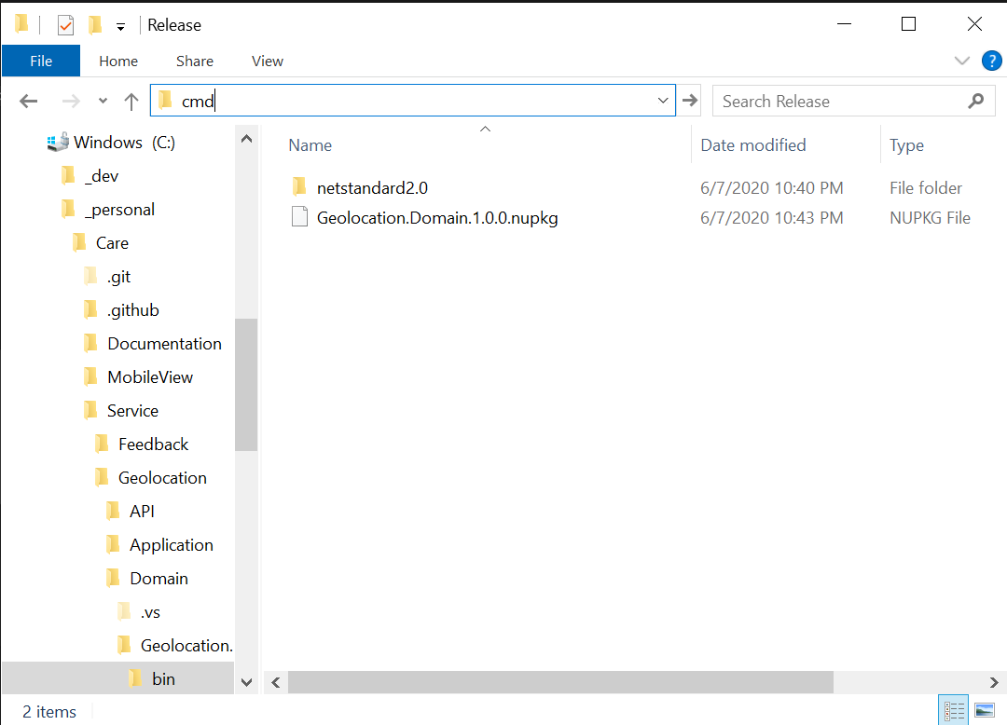

In the new window type “dotnet nuget push $Name.Of.The.Package$ -k $API key$ -s <https://api.nuget.org/v3/index.json>”



A script can be created but careful, do not push your API key to source, keep it private.

## View published package

On the website, go to “manage packages” 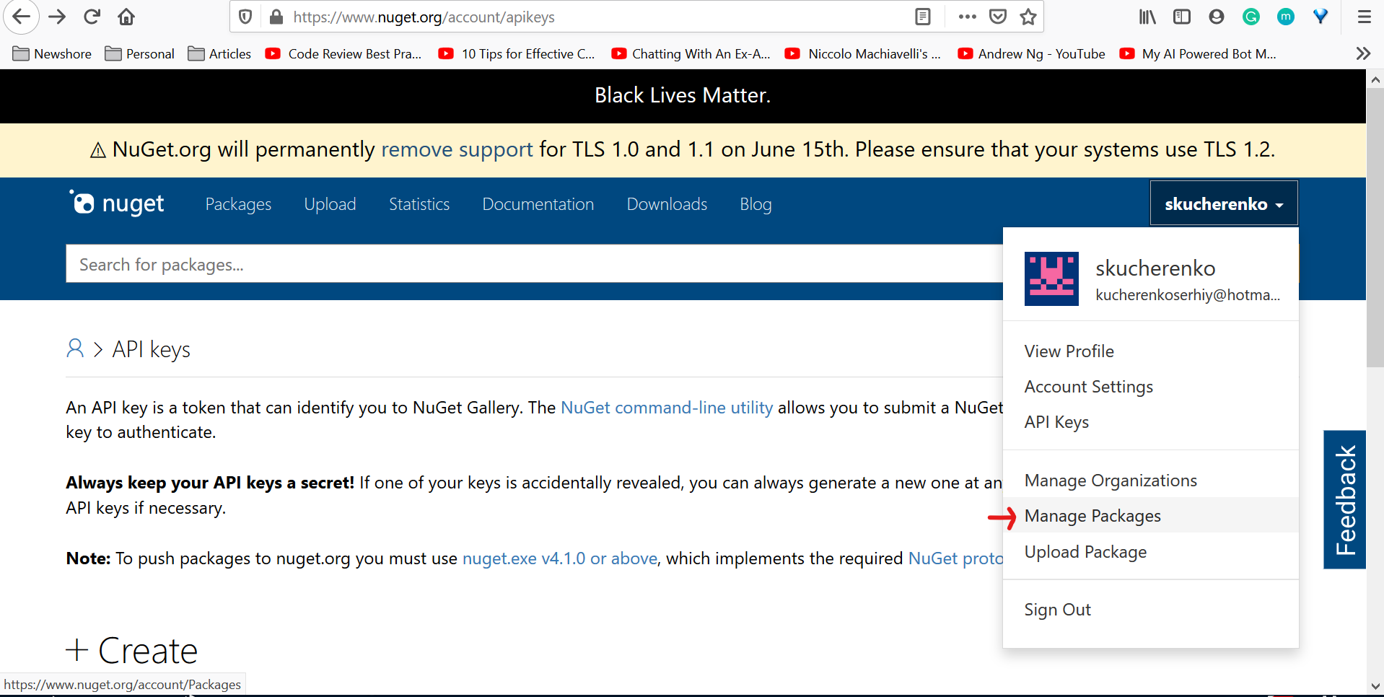

Here you can see the published packages

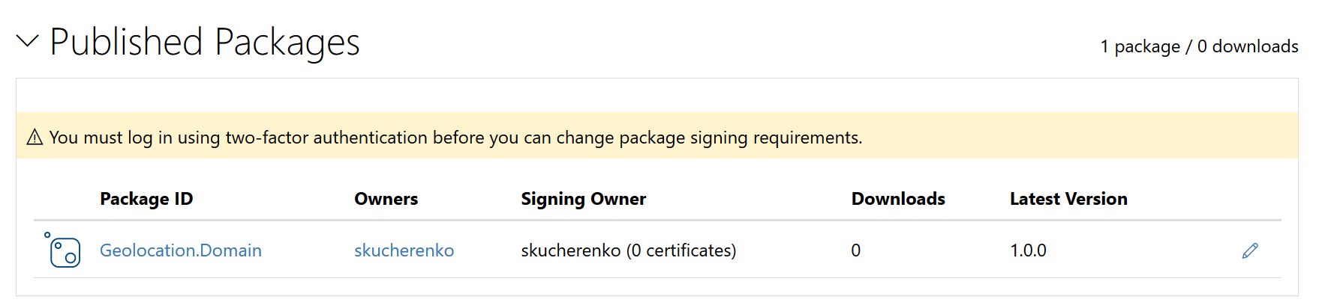

And now you can use it from another solution

